- Declare variables using var, let, and const.
var studentName = "Shanmuga";
let age = 23;
const country = "India";

console.log("var" + " " + studentName);
console.log("let" + " " + age);
console.log("const" + " " + country);

output:
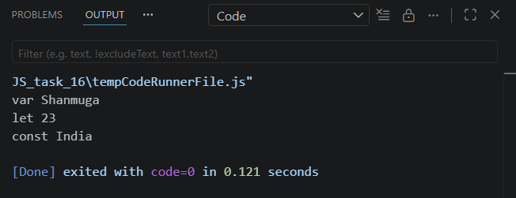

- Create variables with string, number, boolean, null, undefined.
let str = "Hello Everyone"; // string
let num = 10; // number
let isCheck = true; // boolean
let emptyValue = null; // null
let notDefined; // undefined

console.log(typeof(str) + " " + str);
console.log(typeof(num) + " " + num);
console.log(typeof(isCheck) + " " + isCheck);
console.log(typeof(emptyValue) + " " + emptyValue);
console.log(typeof(notDefined) + " " + notDefined);

output:
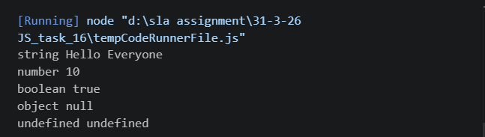

- Use +, -, *, /, %, ==, ===, &&, ||.
let a = 10;
let b = 5;

console.log("Addition:", a + b); // +
console.log("Subtraction:", a - b); // -
console.log("Multiplication:", a * b); // *
console.log("Division:", a / b); // /
console.log("Modulus:", a % b); // %

console.log(a == "10"); // true
console.log(a === "10"); // false

console.log(true && false); // AND
console.log(true || false); // OR

output:
